Historical bat house occupancy of Myotis lucifugus in the Beaverhill Bird Observatory, Alberta: Implications of bat house design in relation to sun exposure

Maria Mejia

Internship Mentor:
Lizelle Odendaal

For
Beaverhill Bird Observatory, Beaver County, Alberta

2023

Introduction
Bats belong to the Order Chiroptera, accounting for one-fifth of the global mammal species (Mickleburgh et al. 2002). Globally, over 16% of bat species are classified as threatened under the IUCN Red List (2022), with 43 % of bats at risk due to habitat loss, and 33 % due to hunting (IUCN, 2022). In addition, emergent threats such as climate change, disease, fires, and anthropogenic infrastructure also play a key role in population declines on the global scale (Sherwin et al., 2013; O’Shea et al., 2016; Frick et al., 2017). In North America bats are among the most diverse and abundant fauna of mammals with 45 species occurring in the United States and Canada (Hammerson et al. 2017). Canada is home to 18 species of bats, while the province of Alberta is home to nine species including the Myotis lucifugus (Little brown bat) listed as Endangered in Canada under the Species at Risk Act (2013). In North America, bats are the primary predators of night-flying insects, including agricultural and forest pests. It is estimated that a single Little brown bat can consume approximately 1,200 insects every hour, saving the agricultural industry millions of dollars on pest control (Ducummon, 2000, Kunz et al., 2011).
Myotis lucifugus can be identified by its glossy fur, small body dimensions of approximately eight to 10 cm in length, and rounded ears. Even though Little brown bats are one of the most common species in North America, they continue to experience novel threats and declines in their global range, mostly caused by disease, habitat loss, and the rise of renewable energy infrastructure (O’Shea et al., 2016). Furthermore, White-nose Syndrome, a disease that negatively affects bat populations, was first detected in New York in 2006 and has continued to spread to Western and Eastern North America, including Alberta, where it was first detected in 2022 (Blejwas et al., 2023; Government of Alberta, 2023). The disease is caused by the fungus Pseudogymnoascus destructans, which covers their noses and wing membranes disrupting their hibernation cycle when immune responses and body temperatures are low (Bauma et al., 2010). In addition, the fungus is known to cause the reduction of body fat storage leading to starvation and death (Verant et al., 2014). The population of Myotis bats has declined by 94% in Canada alone due to White-nose Syndrome and habitat loss (Species at Risk Act, 2018). Due to the increased threat facing bats in North America, especially the once abundant Myotis lucifugus, long-term monitoring projects are required to implement effective conservation strategies, while gathering valuable data that can contribute to management actions.
In spring, Little brown bats emerge from hibernation and migrate to their summer habitat, with females emerging earlier to give birth (Norquay and Willis, 2014). Throughout the summer, female and male bats roost in separate colonies with females being more likely to relocate within summer roosting sites, although roost fidelity for both females and males is significantly high (Norquay et al., 2013). Environmental factors such as ambient temperature play an important role in roost selection and patterns of behavior between colonies (Humphries et al., 2002). Female bats will form maternity colonies where hundreds of bats huddle together to generate warm temperatures and take advantage of social thermoregulation to raise young (Olson and Barclay, 2013). Warm maternity colonies are essential for pup survival, fetal growth, milk production, and juvenile development. In contrast, males prefer cooler temperatures with fewer individuals, sometimes one or two sharing a roost (Webber and Willis, 2018). Little brown bats are known to commonly use man-made wooden boxes, referred to as bat boxes or bat houses, designed to provide additional roosting spaces or to enhance habitat, particularly in areas where natural roost spaces may be limited (Rueegger, 2016). Bat houses can provide warmer internal microhabitats that are highly preferred by bats (Fontaine et al., 2021). Microclimates inside boxes are influenced by factors such as box design, orientation, color, sun exposure, house material, and total occupancy (Brittingham and Williams, 2000; Griffiths et al., 2017). Little brown bats can maintain internal temperatures with minimum metabolic regulation when the temperature inside the bat house is approximately 32-37 °C (Studier and O’Farrell, 1976). Temperatures below 20 °C can induce torpor, which reduces physiological activity and lactation (Henry, 2003). On the other hand, high temperatures above 40 °C, can cause detrimental effects such as heat stroke, dehydration, or death (Henry, 2003; Flaquer et al., 2014; Griffiths, 2021). Nevertheless, bat houses can create additional roosting opportunities for bats, and they can be used as a tool in bat conservation efforts when proper management is implemented (Fontaine et al., 2021).
The Beaverhill Bird Observatory (BBO) operates a long-term monitoring program of bat houses to enhance and quantify bat house occupancy and study roosting preference within the Beaverhill Natural Area (BNA). The study was designed as part of a monitoring program of bat houses to assess the effectiveness of bat house design between different habitats in the region (Interior, Clearing, Open, and Edge). Previous monitoring reports showed that: (i) Multi-chambered houses are generally preferred, given that several single-chambered houses have consistently had very low (<20 total individuals) occupancy numbers ( Abernethy & Meijerink, 2020; Waldron & Burke, 2021; Lewicki et al. 2022). (ii) Daily maximum temperature can influence bat house occupancy, but this was not evident across all years (Lewicki et al., 2022). (iii) Bat house occupancy is influenced by the nearest distance to water as bat houses located closest to water had high occupancy (Lewicki et al., 2022).
The overall aim of this study is to build on data collected over the last few years (2020 - 2023) to continue looking at long-term trends, enabling us to determine the overall success of the bat house monitoring program at Beaverhill Natural Area. In particular, given that results from previous years have consistently shown that multi-chambered bat houses are preferred over single-chamber houses (as is evident by the consistently low bat house occupancy numbers over several years), we also used a subset of the data focusing on multi-chambered bat houses, to determine whether differences in sun exposure levels could also influence bat house occupancy in multi-chambered bat houses, analyses that have previously not been done. Historical data trends can help to make important strategic decisions when choosing bat house design and habitat placement, in addition to identifying areas of improvement and predictions about future trends.
Methods
Study Area
The bat houses' occupancy surveys occurred at the Beaverhill Natural Area (BNA) (53.3672220, -112.54170) located 7.8 km east of Tofield, Alberta; within the Parkland Natural Region and Central Parkland Natural Subregion (Natural Regions Committee, 2006). Several different habitat types including forest, wetland, and grassland are found in the area. The dominant vegetation for forested areas includes Populus tremuloides (Trembling aspen), P. balsamifera (Balsam poplar), an understory of shrubs and forbs. The wetland habitat is mostly dominated by Typha latifolia (Cattail), Carex (sedges), and Salix (willow) species, while the grasslands are dominated by a variety of tame pasture and native grasses and forbs.
The bat houses are located within the three habitats, including four habitat categories such as clearing, interior forested areas, edge, and open habitat (Figure 1.). Most houses are attached to trees, while others include poles/posts for areas of open habitat. There are currently 39 bat houses along the survey route (Figure. 2). Houses varied in size and type: small single chamber, large single chamber, and multi-chamber (Figure. 3). Colour also varied between houses: red, brown, and blue (Appendix 1). Occupancy surveys were conducted weekly from May 19, 2023, to September 8th, 2023. The surveys were completed half an hour before sunset and before bat emergence. Weather data was recorded at the beginning and end of each survey, including temperature (°C), cloud cover (%), wind speed (km/h), wind direction, and precipitation (mm). The weather data was obtained from the Tofield Weather Network App; the Beaverhill Natural Area is located 12 km from the town of Tofield, Alberta, and therefore is assumed to be affected by similar weather conditions.
Occupancy numbers were collected using a flashlight to briefly shine at the interior of the bat house and quickly count the numbers to reduce exposure and limit disruption to bats. Some issues were encountered while estimating occupancy numbers to bat houses with large numbers of bats, especially those that were used as maternity roosts for bat colonies. This prevented numbers from being exact, while data corresponded to estimated counts rather than true numbers of bats.
Historical data from 2020 - 2022 was used, including data from the current year (2023) to estimate bat preferences on bat house types. Since 2020 a total of six multi-chamber houses have been added to the BBO monitoring program (Appendix 1).

Statistical Analysis:
Non-parametric statistical analyses, Mann Whitney U-test, and Kruskal-Wallis Test were conducted using Microsoft Excel (version 2308) to evaluate a significant difference in bat house occupancy between i) bat house type (ii) bat houses exposed to different levels of sunlight and (iii) bat house sizes. Bar charts were used to visualize the difference in bat house occupancy between these variables and occupancy rates, and historical bat survey counts were plotted against each variable. Non-parametric tests were performed for data analysis, as our data set is not normally distributed, and does not meet the assumptions of normality (the number of bats on each house are not independent variables). The Kruskal-Wallis test was used to determine if there was a significant difference between occupancy rates of multi-chamber houses regarding sunlight exposure (mostly shade, mostly sunny, and partial sun). In addition, the Kruskal-Wallis test was used to identify any significant difference between large, medium, and small multi-chamber houses. Furthermore, a Mann-Whitney U-test was conducted to determine if there is a difference between multi-chamber houses located across the edge and the interior habitat. The null hypothesis looks to test if there is no significant difference in historical bat occupancy preference between multi-chambered houses exposed to greater sunlight, house size, and habitat type.
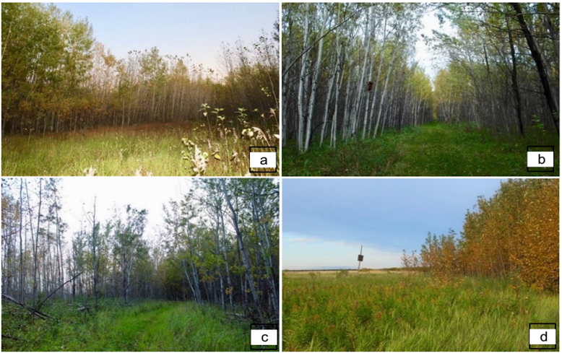
Figure 1. Four habitat types were found along the Beaverhill Natural Area bat occupancy survey transect. (A) Clearing: open areas within the interior forest. (B) Interior: Forested dominated by Populus Tremuloides and P. Balsamifera. (C) Edge: forested areas within an edge. (D) Open: open habitat mostly dominated by grass species (Low, 2023).
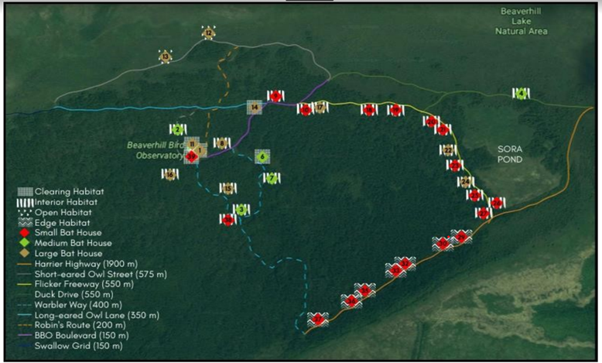
Figure 2. Map of bat houses between the Beaverhill Natural Area. Houses M42, M43, M44, M45, M46 are not included on the map diagram. Houses 4 and 5 are currently decommissioned. (Gualter and Halajian 2019).

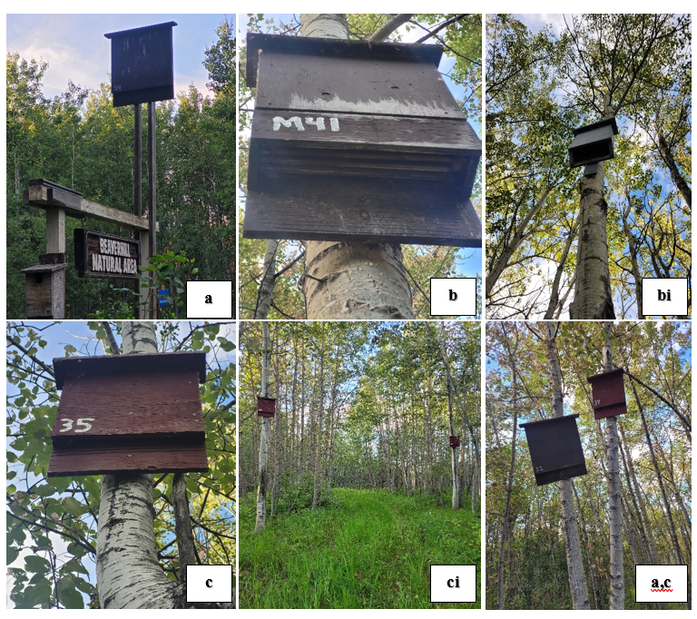Figure 3. Beaverhill Bird Observatory bat houses design. (a) Large brown single chamber. (b) Brown large multi-chamber. (bi) Blue medium multi-chamber. (c) Small red single chamber. (ci) Small red single chamber on edge habitat. (a,c) Large brown single chamber (left) and small red single chamber (right) (Mejia, 2023).
Results
Bat House Occupancy Over Four Years
Myotis lucifugus was visually observed roosting in the bat houses of the BNA. A total of 2137 were observed roosting in 2023 along all house sizes and across habitat types. In comparison, a total of 645 bats were counted in 2020, 1547 in 2021, and 2195 in 2022. Additionally, a decrease of 2.64% in bat occupancy was observed between 2022 and 2023 (Figure 4).
The highest occupied houses at the BNA are multi-chamber houses. House M41 has had the highest occupancy rate of the multi-chamber houses, and all houses in general throughout four consecutive years, for a total of 1410 bat observations (Table 1). Throughout the study in the summer of 2023, it was noted that overall occupancy was higher in multi-chamber bat houses for a total of 1943 bat observations, compared to 194 bat observations in small and medium single-chamber houses.
Multi-chamber houses located in areas with increased sun exposure also presented a higher rate of total bat occupancy. Houses located in areas with direct sun (mostly sunny) on edge habitats have on average a greater bat occupancy, followed by partial sun exposure. Mostly shaded locations in edge and interior habitats had less bat house occupancy preference. (Figure 5). Furthermore, the sum of bat occupancy on multi-chambered houses across the four consecutive years, shows that occupancy is higher on houses located in areas with partial sun (only morning or afternoon sun), whereas mostly sunny and shaded areas have the least preference (Figure 6), nevertheless, these results are a reflection of raw data of the total number of multi-chamber houses and bat observations. The number of multi-chamber houses in partially sunny areas is higher compared to the ones located in direct or shaded sunlight (Appendix 1).
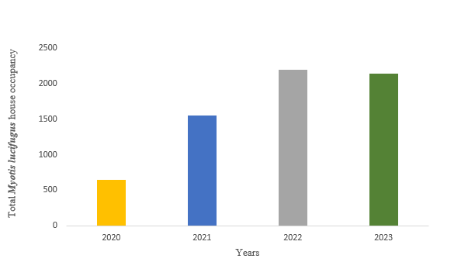
Figure 4. Total number of bat house occupancy (N= number of individuals) across four
consecutive years (2020, 2021, 2022 and 2023).

Table 1. Bat houses consistently occupied by > 20 individuals for at least two consecutive years.

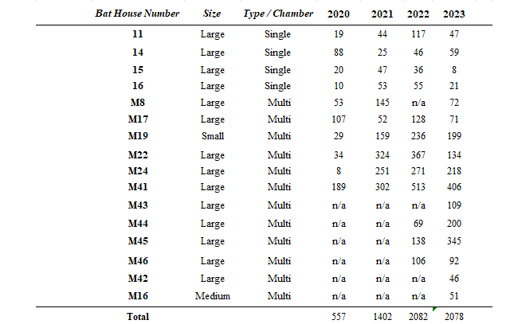

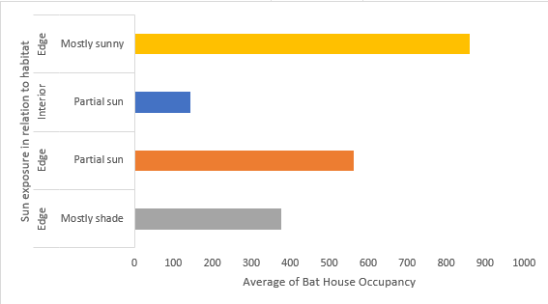
Figure 5. Average occupancy of multichambered houses related to sunlight exposure (Mostly sunny, Partial sunny, Mostly shade) across the edge and interior habitat types.

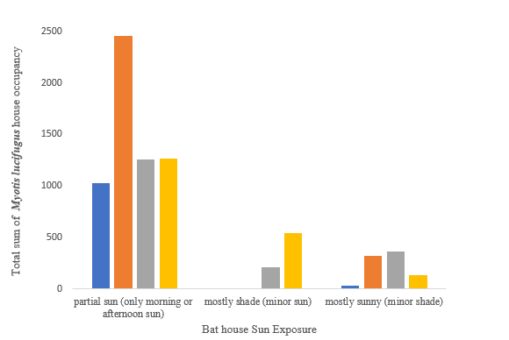
Figure 6. (Partial sun, Mostly shade, and Mostly sunny). Over the course of four years
(2020,2021,2022, and 2023).

Non-Parametric Statistical Analysis
For the statistical analysis of occupancy rates between multi-chamber houses located on mostly shade, partially sunny, and mostly sunny the K value (Kruskal-Wallis Test; K=11.82; p<0.01) was larger than the critical value (Kruskal-Wallis Test; critical=9.21; p<0.01). Therefore, we reject the null hypothesis and there is a significant difference between the medians of the three sunlight exposures across multi-chamber houses. There is a preference for partial sun exposure (R^2=455.1), followed by mostly sunny (R^2=121), in comparison to mostly shaded (R^2=84.5). In contrast, the occupancy rates between large, medium, and small multi-chamber houses; the K value (Kruskal-Wallis Test; K=1.15; p<0.01) was smaller than the critical value (Kruskal-Wallis Test; critical=9.21; p<0.01). Therefore, we fail to reject the null hypothesis and there is no significant difference between the medians of the three bat house sizes in relation to bat occupancy.

Multi-chamber houses across the Beaverhill Natural Area are located between two habitat types; edge, and interior. The Mann-Whitney U-Test was conducted to determine if there is a difference between multi-chamber houses located across the edge and the interior habitat. The smaller U-test value (Mann-Whitney U-test; U=5; p<0.05) was larger than the critical value (Mann-Whitney U-test; critical=2; P < 0.05). Therefore, we fail to reject the null hypothesis and there is no significant difference in bat house occupancy numbers between edge and interior habitats.
Discussion
The results suggest that bats prefer multi-chamber houses that are located in areas with greater sunlight exposure. Multi-chamber houses are the most preferred for maternity roost colonies at the Beaverhill Natural Area, and those houses located in areas of major sunlight exposure should have a greater preference in comparison to others in shaded locations. The results of bat occupancy monitoring throughout four consecutive years (2020 - 2023) indicate an increase in the number of bats using the houses at the BNA. Nevertheless, a slight reduction of 2.64% in bat occupancy was observed in 2023 compared to 2022. This is likely due to the survey's effort, as during the last two weeks of July 2023 the BBO was inaccessible due to flooding in the natural area, and surveys were unable to be completed during this time. Furthermore, the BBO has increased the number of bat houses in the previous year including four more additional houses in 2023.
Multi-chamber houses have shown a higher preference than single-chamber houses across multiple years (Low, 2017; Caron & Hlewka, 2018; Gualter & Halajian, 2019; Abernethy and Meijerink, 2020). We also compared the differences in sun exposure between multi-chamber houses, and the statistical results suggest a strong correlation between house occupancy and direct sunlight exposure. These results support the findings of Brittingham and Williams (2000), who suggested that Myotis lucifugus prefers bat houses that are exposed to >7 hours of direct sunlight with wide chambers to allow bats to move and snuggle for warmth. Mounting bat houses to face areas of longer sunlight can reduce 8% of bats' daily metabolic energy cost used by lactating females (Fontaine et al., 2021). Several studies also suggest that placing bat houses in south and east orientations increases bat occupancy, especially in areas with temperate environments (Long et al., 2006; Dillingham et al., 2003; Fontaine et al., 2021).

Our study focused on multichambered bat houses. Showed higher occupancy numbers in houses exposed to direct sunlight than houses in more shaded locations. We found no influence of habitat type or bat house size on bat house occupancy numbers, suggesting that hours of direct sun exposure may be a critical requirement for a successful bat house location. Previous studies of Australian (Griffiths, 2021) and European (Henry, 2003; Flaquer et al., 2014) bat houses have indicated an upper lethal limit of 20-37 °C. If Myotis lucifugus is similar, then very high temperatures could also be detrimental as overheating of internal bat houses can be lethal to bats (Griffiths, 2021). Leung et al., (2022), identified that black bat houses exposed to long periods of sunlight can increase internal house temperature to threatening levels, they suggested that to enhance habitat, a proper practice is to locate an additional house with white-roofing adjacent to dark houses, this way bats have chances to relocate if temperatures are too high. Although this study did not focus on the internal temperature of each house at the BNA, it is important to consider recording thermodynamic data of bat boxes to test the effect of internal temperature and understand roosting colony trends at the BNA.
Previous BBO reports found that single-chamber houses were still occupied in August and September, in contrast to multi-chamber houses where a significant decline during those months is observed (Waldron et al., 2021). It's possible that these bat houses were occupied by males, who often roost in small groups, and take longer to migrate, compared to female bats (Norquay and Willis, 2014). Although multi-chamber houses show the most significant effect on occupancy rates favoring maternity colonies, it is important to acknowledge the role of single-chamber houses at the BNA. A previous study at the BBO suggested that proximity to water plays an essential role in the success of high rates of bat observations (Lewicki et al. 2022). These results, together with our analyses showing the importance of direct sun exposure, suggest that Myotis lucifugus shows a preference for locations that offer direct sunlight in addition to areas of high foraging opportunities. Little brown bats are a species at risk, and finding alternative ways to improve the quality of artificial structures such as bat houses is beneficial for conservation efforts. Although bat houses have been increasing in popularity, it is important to recognize that efficiency can vary depending on multiple factors, such as placement, habitat, and sunlight exposure. Bat houses can be thermally unstable structures (Griffiths, 2021); however, improving the thermodynamics of internal temperature by exposing the houses to proper sunlight, can aim to facilitate and enhance habitat quality, especially for maternity colonies (Fontaine et al., 2021).

Recommendations
We recommend continuing to install multi-chamber bat houses, preferably in all of the habitat categories in the area. In doing so, a more robust analysis of habitat preferences can be made. Furthermore, areas that can provide forage opportunities such as closer to water bodies and in locations with bright direct sunlight (>7 hours a day) should be preferred. It is also important to consider new areas of study for future reports that include internal bat house thermoregulatory data, which can allow us to directly monitor the internal thermo dynamics of bat houses at the BNA, thereby using relevant data, instead of daily maximum temperature for the region for analyses. These additional data will allow managers to identify areas of improvement, such as bat house color, material, design, and placement in case of overheating or cooler spells.

Acknowledgments
I would like to thank the Beaverhill Bird Observatory for the opportunity to participate as a bat intern. A special thanks to the biologists, staff, and volunteers at the BBO for their support, including Jana Teefy (BBO Head Biologist) and Jon Van Arragon (Assistant Biologist), for their help with data collection. A special thanks to Lizelle Odendaal and Erin Low for their guidance and support as mentors. A huge thanks to Jazper O’Driscoll for being an incredible intern partner venturing together during the late nights and always making sure we both got home safe. Lastly, thank you to my family and friends for supporting me during this internship.

References
Abernethy, S., & Meijerink, S.P. (2020). 2020 Bat Monitoring Summary at the Beaverhill Bird Observatory. Beaverhill Bird Observatory, Beaver County, Alberta
Blejwas, K., Beard, L., Buchanan, J., Lausen, C. L., Neubaum, D., Tobin, A., & Weller, T. J. (2023). Could white-nose syndrome manifest differently in Myotis lucifugus in Western versus Eastern regions of North America? A review of factors. Journal of Wildlife Diseases.
Brittingham, M. C., & Williams, L. M. (2000). Bat boxes as alternative roosts for displaced bat maternity colonies. Wildlife Society Bulletin, 197-207.
Caron, V., Hlewka, J. (2018). Bat house occupancy monitoring at the Beaverhill Natural Area. Beaverhill Bird Observatory. Retrieved from: http://beaverhillbirds.com/publications/student-interns/
Dillingham, C. P., Cross, S. P., & Dillingham, P. W. (2003). Two environmental factors that influence usage of bat houses in managed forests of southwest Oregon. Northwestern Naturalist, 20-23.
Ducummon, S. L. (2000). Ecological and economic importance of bats. Bat Conservation International, Austin, TX
Feeley, K. J., Stroud, J. T. & Perez, T. M. (2017). Most ‘global’ reviews of species' responses to climate change are not truly global. Diversity and Distributions 23(3), 231–234.
Flaquer, C., Puig, X., López-Baucells, A., Torre, I., Freixas, L., Mas, M., Porres, X., Arrizabalaga, A. (2014). Could overheating turn bat boxes into death traps. Barbastella, 7(1), 46-53.
Fontaine, A., Simard, A., Dubois, B., Dutel, J., & Elliott, K. H. (2021). Using mounting, orientation, and design to improve bat box thermodynamics in a northern temperate environment. Scientific Reports, 11(1), 7728.
Gaulter, J., & Halajian, E. (2019). Occupancy of three bat house sizes across different habitats at the Beaverhill Bird Observatory. Beaverhill Bird Observatory.
Government of Alberta. (2023). White-nose Syndrome. https://www.alberta.ca/white-nose-syndrome. [Accessed October 15, 2023].
Government of Alberta. (n.a). Human-wildlife conflict – Bats. https://www.alberta.ca/bats.aspx#:~:text=There%20are%20at%20least%209,threat%20of%20white%2Dnose%20syndrome. [Accessed July 9, 2023].
Government of Canada. (n.a). Making life better for bats and people in Canada. https://parks.canada.ca/nature/science/especes-species/chauve-souris-canada-bats. [Accessed July 9, 2023].
Griffiths, S. R. (2021). Overheating turns a bat box into a death trap. Pacific Conservation Biology, 28(1), 97-98.
Griffiths, S. R., Bender, R., Godinho, L. N., Lentini, P. E., Lumsden, L. F., & Robert, K. A. (2017). Bat boxes are not a silver bullet conservation tool. Mammal Review, 47(4), 261-265.
Griffiths, S. R., Rowland, J. A., Briscoe, N. J., Lentini, P. E., Handasyde, K. A., Lumsden, L. F., & Robert, K. A. (2017). Surface reflectance drives nest box temperature profiles and thermal suitability for target wildlife. PLoS One, 12(5), e0176951.
Gualter, J., & Halajian, E. (2019). Occupancy of three bay houses sizes across different habitats at the Beaverhill Bird Observatory. Retrieved from: http://beaverhillbirds.com/publications/student-interns/
Henry, M. (2003). Etude de l'ecologie d'une population de petites chauves-souris brunes (Myotis lucifugus Leconte) en vue d'un programme de conservation (French text, Quebec).
Humphries, M. M., Thomas, D. W., & Speakman, J. R. (2002). Climate-mediated energetic constraints on the distribution of hibernating mammals. Nature, 418, 313–316. https://doi.org/10.1038/nature00828
IUCN (2022). The IUCN Red List of Threatened Species. Version 2022-1. Electronic file available at https://www.iucnredlist.org. [Accessed October 15, 2023].
Kunz, T. H., Braun de Torrez, E., Bauer, D., Lobova, T., & Fleming, T. H. (2011). Ecosystem services provided by bats. Annals of the New York academy of sciences, 1223(1), 1-38.
Leung, M. C., Reid, D. G., & Halliday, W. D. (2022). Sun hats for bat boxes: Mitigating the risk of overheating at Northern Lattitudes. Northwestern Naturalist, 103(3), 226-235.
Lewicki, H. M., Odendaal, L., & Low, E. (2022). Impact of Weather Conditions and Proximity to Water on Bat House Occupancy in the Beaverhill Natural Area. Beaverhill Bird Observatory, Beaver County, Alberta.
Long, R., Kiser, W., & Kiser, S. (2006). Well-placed bat houses can attract bats to Central Valley farms. California Agriculture, 60(2), 91-94.
Low, E. (2017). Occupancy monitoring of bat houses at Beaverhill Bird Observatory in 2017. Beaverhill Bird Observatory. Retrieved from: http://beaverhillbirds.com/publications/student-interns/
Low, E. (2023). Bat internship: Internship information packet Beaverhill Bird Observatory.
Mickleburgh, S. P., Hutson, A. M., & Racey, P. A. (2002). A review of the global conservation status of bats. Oryx, 36(1), 18-34.
Microsoft. (2023). Excel (Version 2308) [Computer software]. Redmond, WA: Microsoft.
Natural Regions Committee. (2006). Natural Regions and Subregions of Alberta. Compiled by D.J. Downing and W.W. Pettapiece. Government of Alberta. Pub. No. T/852.
Neilson, A. L., & Fenton, M. B. (1994). Responses of Little Brown Myotis to Exclusion and to Bat Houses. Wildlife Society Bulletin (1973-2006), 22(1), 8–14. http://www.jstor.org/stable/3783215
Norquay, K. J. O., & Willis, C. K. R. (2014). Hibernation phenology of Myotis lucifugus. Journal of Zoology, 294(2), 85-92.
Norquay, K. J., Martinez-Nuñez, F., Dubois, J. E., Monson, K. M., & Willis, C. K. (2013). Long-distance movements of little brown bats (Myotis lucifugus). Journal of mammalogy, 94(2), 506-515.
Olson, Cory R., and Robert MR Barclay. Concurrent changes in group size and roost use by reproductive female little brown bats (Myotis lucifugus). Canadian Journal of Zoology 91, no. 3 (2013): 149-155.
O'Shea, T. J., Cryan, P. M., Hayman, D. T., Plowright, R. K., & Streicker, D. G. (2016). Multiple mortality events in bats: a global review. Mammal review, 46(3), 175-190.
Rueegger, N. (2016). Bat boxes—a review of their use and application, past, present and future. Acta Chiropterologica, 18(1), 279-299.
Sherwin, H. A., Montgomery, W. I. & Lundy, M. G. (2013). The impact and implications of climate change for bats. Mammal Review 43(3), 171–182.
Species at Risk Act, 2018. Recovery Strategy for Little Brown Myotis (Myotis lucifugus), the Northern Myotis (Myotis Septentrionalis), and the Tri-colored Bat (Perimyotis subflavus) in Canada. https://www.registrelep-sararegistry.gc.ca/virtual_sara/files/plans/Rs-TroisChauveSourisThreeBats-v01-2019Nov-Eng.pdf
Studier, E. H., & O'Farrell, M. J. (1976). Biology of Myotis thysanodes and M. lucifugus (Chiroptera: Vespertilionidae)—III. Metabolism, heart rate, breathing rate, evaporative water loss and general energetics. Comparative Biochemistry and Physiology Part A: Physiology, 54(4), 423-432.
Verant, M. L., Meteyer, C. U., Speakman, J. R., Cryan, P. M., Lorch, J. M., & Blehert, D. S. (2014). White-nose syndrome initiates a cascade of physiologic disturbances in the hibernating bat host. BMC physiology, 14(1), 1-11.
Waldron, C., Burke, K., Mentor, I., & Low, E. (2021). Occupancy of Myotis lucifugus among various bat house designs. Beaverhill Bird Observatory, Beaver County, Alberta
Webber, Q. M., & Willis, C. K. (2018). An experimental test of effects of ambient temperature and roost quality on aggregation by little brown bats (Myotis lucifugus). Journal of Thermal Biology, 74, 174-180.

Appendix 1

